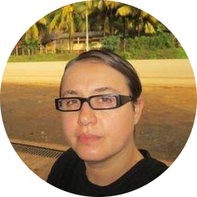 | 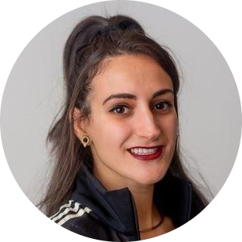 |  | 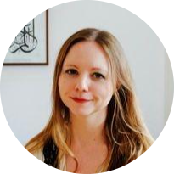
Professor Silvia Posocco  (Psychosocial/Sociology) | Dr Ivana Bevilacqua  (Geography) | Ms Joy Brooks-Gilzeane  (Politics) | Dr Sarah Marks  (History)

